Butto n | No light | Flashing | Steady light
 | Machine is run‐ ning fault-free. | A fault has occurred.
 |  | The relevant mes‐ sage is displayed in the status bar on the screen.
 |  | Press button to acknowledge mes‐ sage.

3.4.2 Layout of the rear side
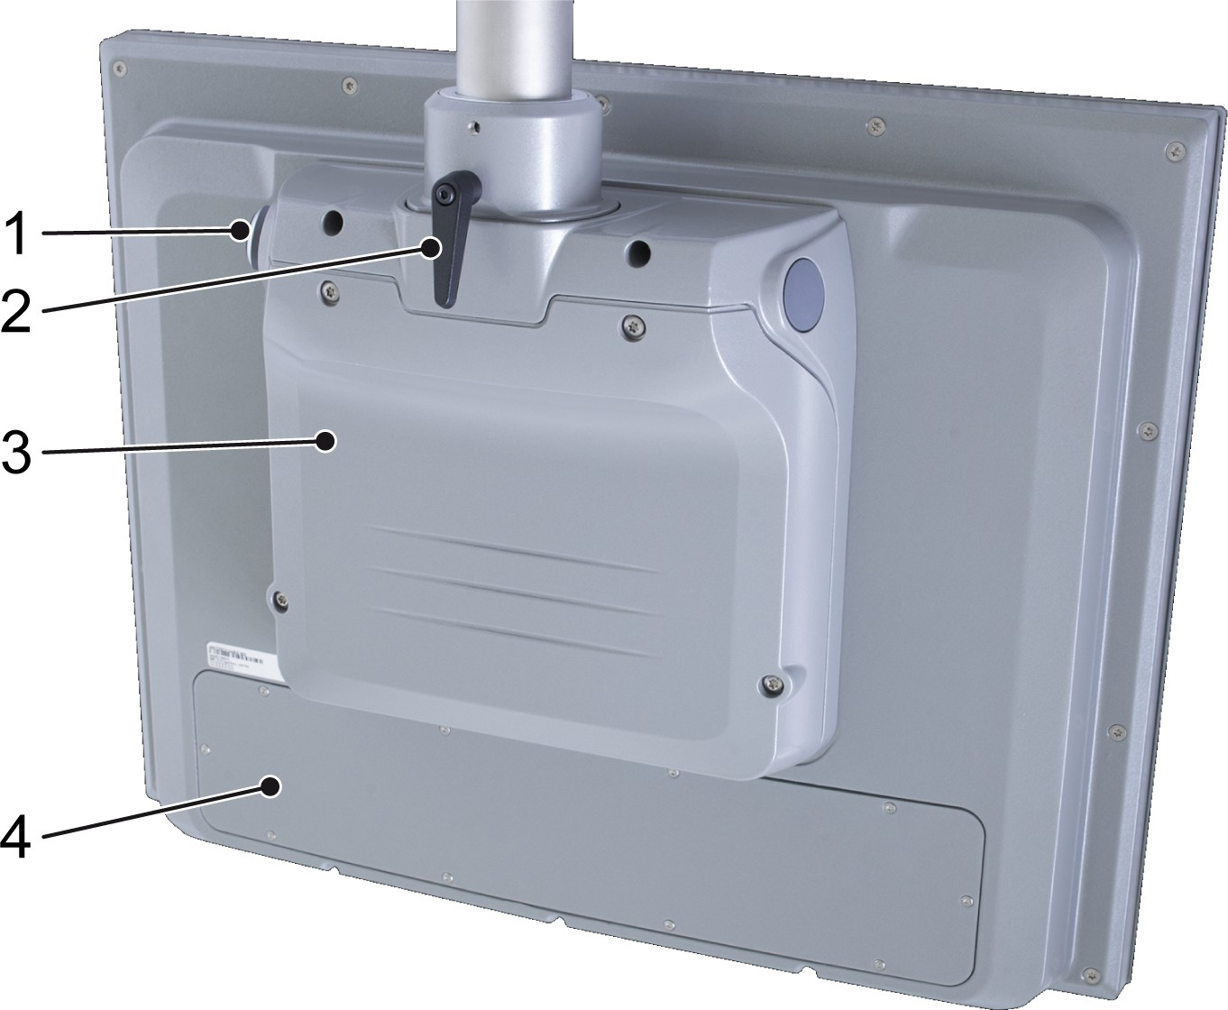

Figure 54: Rear of the operator console, hanging version
- USB port
- Lever for locking the rotary joint
- Computer cover
- Cover for the operating controls circuit

Function
The industrial PC on which the graphical user interface is running can be installed either in the switch cabinet or at the rear of the operator console. The user can insert the USB stick into the USB port and can then save screenshots or other data to it, for example.

The user can use the lever to adjust the rotation of the operator console.

Graphical user interface at the infeed of the "Separate" process module
When the term "machine" is used in this chapter, only the front sec‐ tion of the machine is meant.

This section describes the functions of the graphical user interface that are enabled for the predefined operator user role.

Main window
The main window is visible when the screen is on.
The main window is subdivided into several areas. The figure shows the areas that are always visible.
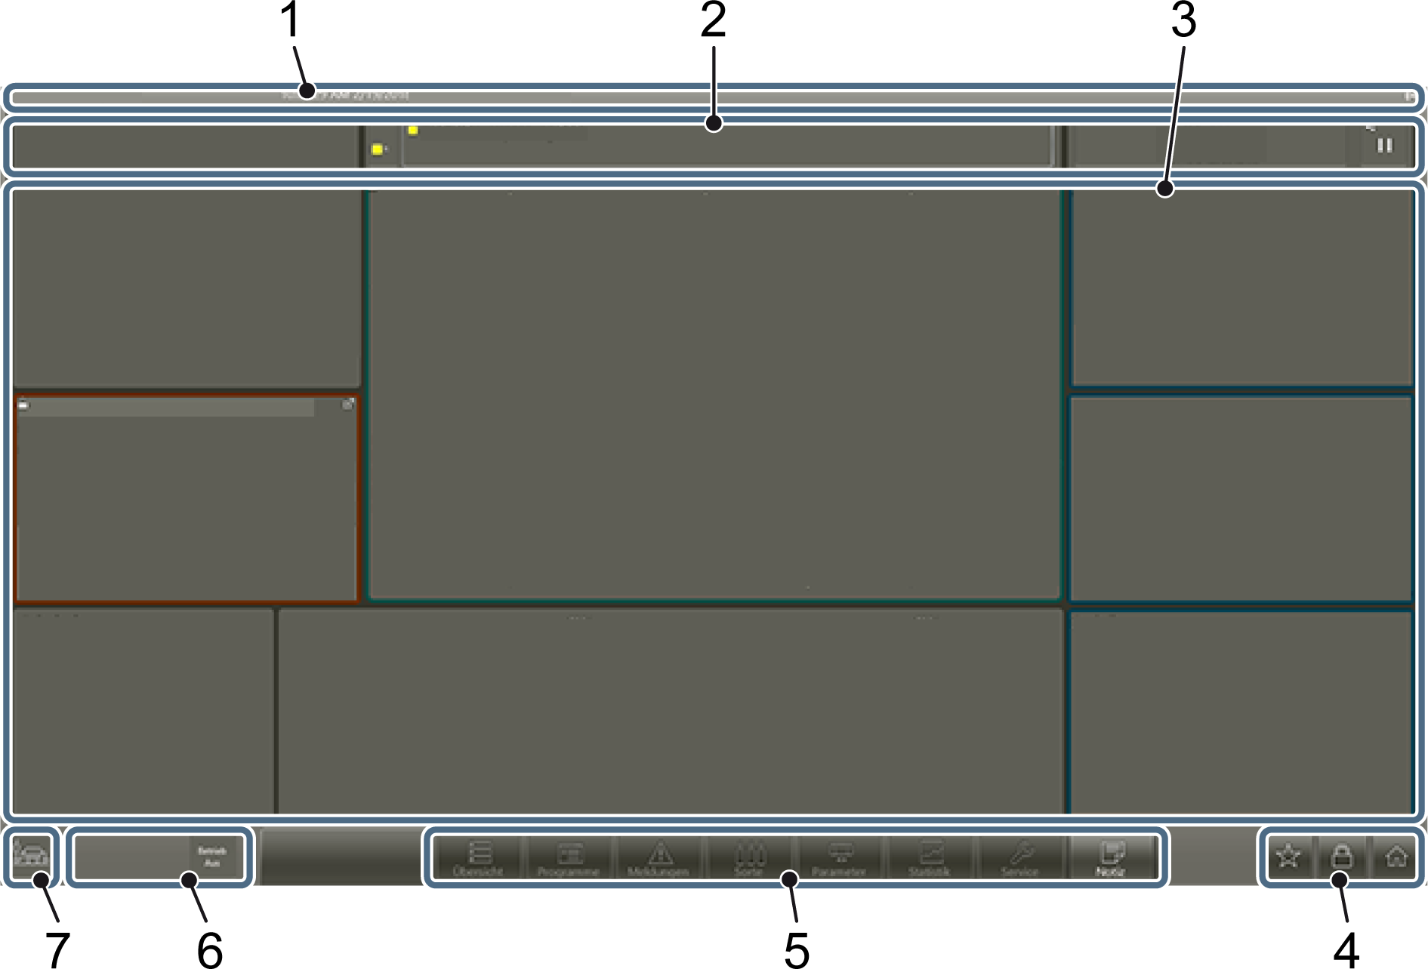

Figure 55: Window areas in the main window
- Title bar
- Status bar
- Work area
- Icon bar
- Menu bar
- Machine functions
- Machine icon

Title bar
The title bar contains assignment information. It shows, from left to right:
- Name of the machine controlled with the program
- Current date and time
- Name of the person logged in
- Icon for the RFID connection

Status bar
The status bar shows the status of the machine.

Figure 56: Status bar
The status bar is divided into the following areas (from left to right):
- Display of the service interval
- Message area for fault messages
- Display of the current program and type
- Machine status

Messages
A message appears in the status bar in the event of a fault or if a machine requires an action to be taken. In addition, the machine icon is outlined in the colour corresponding to the message type.

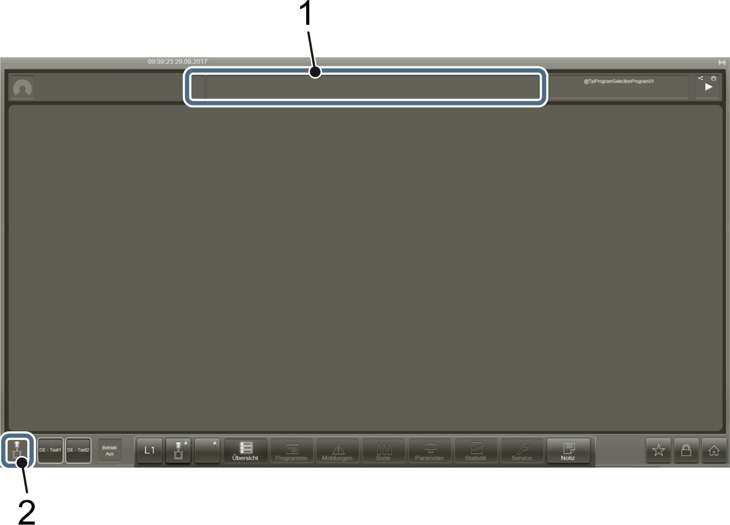

Figure 57: Message areas in the main window
- Machine-specific output fields
- Machine icon
A message has the following components, from left to right:
- Code colour
- Code letter
- Message number
- Message text
Example
‘F0001 electrical surge protection, switch cabinet’
The code colour and code letter characterise the message type:

Code colour | Code letter | Message type
Red | C | Critical fault
Blue | F | Faults
Yellow | W | Warning
White | I | Information
Message number and message text identify the cause of the mes‐ sage.
The message area in the status bar is split into two:

Figure 58: Message area
- On the left, shortened to the colour icon, all fault message types with their number, sorted according to urgency. If the user taps this field, the ‘Current messages’ view opens.
- The message text of the first critical message is on the right. When the user taps this field, a dialogue containing detailed infor‐ mation for the message opens.
The user must resolve the cause of the message and acknowledge the message before they can start the machine.

Responding to messages
Personnel:  Operating personnel

- Touch the message in the status bar.
  - A dialog with detailed information about the message opens.
- Remedy the cause of the message as described.
- Close the dialog with ‘X’ .

- If the button on the operator console is flashing, press the button to acknowledge the message.

Machine status
Machine status combines operating status and operating mode.

Operating status

Icon | Meaning
Machine is running. Machine not running.
Production stopped
 | Transition between two statuses

Operating mode

Icon | Meaning
 | Automatic mode
 | Semi-automatic mode
 | Setup mode
 | Teleservice

Machine status dialogue
The ‘Machine status’ dialog opens when the operator taps the machine status output field in the status bar. The ‘Machine status’ dialogue shows the status of the machine in a different way.
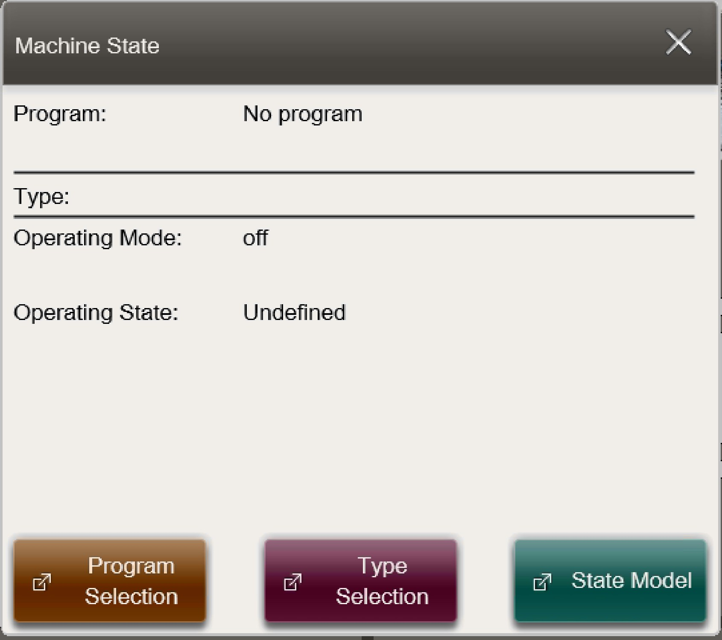

Figure 59: Machine status dialogue
Viewed from top to bottom, this dialogue gives the following details:
- ‘Program’ : current program
- ‘Type’ : current type
- ‘Operating mode’ : current operating mode
- ‘Operating status’ : current machine status

The buttons at the bottom in the dialogue have the following mean‐ ings:

Actions

Button | Meaning
‘Program selection’ | Opens the ‘Program selection’ view.
‘Type selection’ | Opens the ‘Type selection’ view.
‘Status model’ | Opens the ‘Status model’ view.

      - Work area
In the work area, there are different types of content:
- Dashboard
- Individual views
- Assistants (several views in sequence)

Dashboard
The dashboard fills out the entire work area and contains all the important information about the machine. The user has an overview of the current machine status and can quickly navigate to key views.
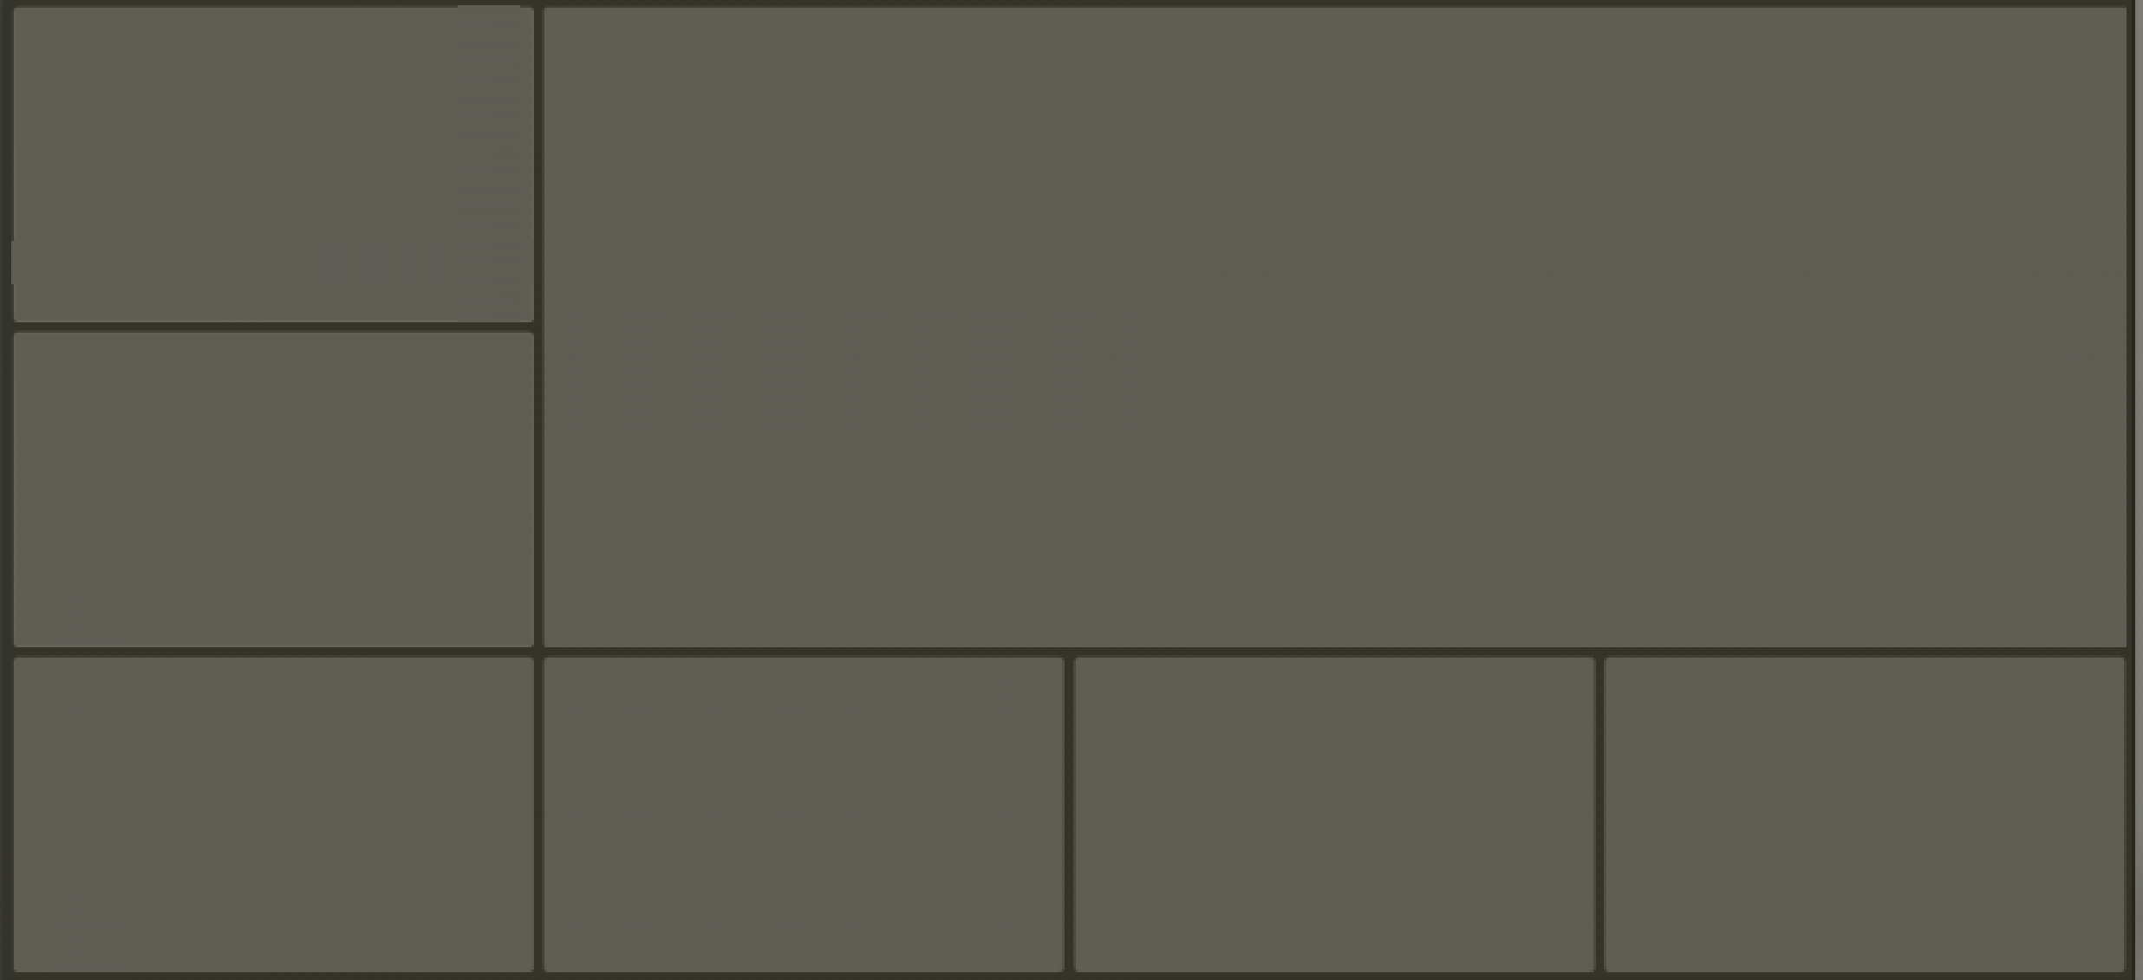

Figure 60: Dashboard
The top right of the dashboard contains an image of the machine sup‐ plying the displayed values. Overviews of particular machine parame‐ ters are arranged around it.

The user can open the linked view by clicking .

Views
A view will open on the dashboard showing detailed information and settings for the line, machine or component selected.

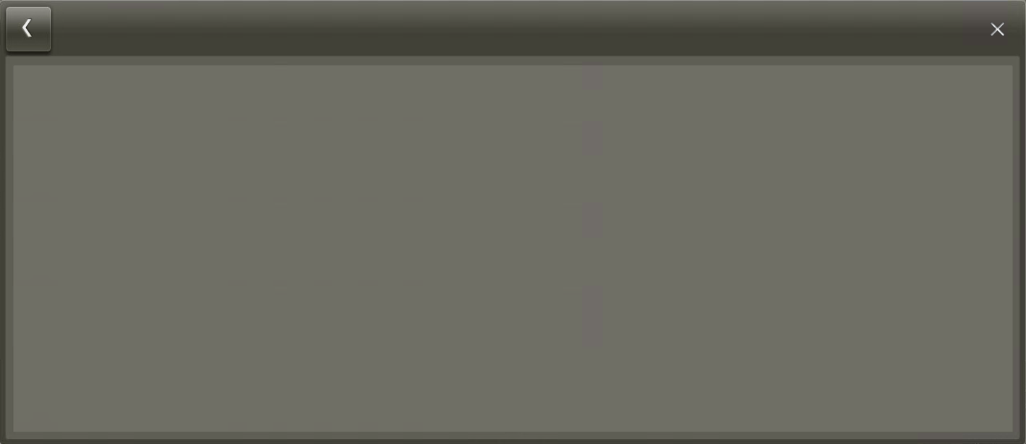

Figure 61: View
Each view has a name which is shown at the top left. The line, machine or component to which the view applies is displayed under‐ neath the name.

Scrolling and browsing
If there is more information than fits in the visible area, it can be arranged in two ways:
- The information is distributed on several pages and the user can browse through the pages of the view. Arrows for browsing for‐ ward and backward are at the top of the view.
- The information is all on one page and the user can scroll verti‐ cally through the view. The scroll bar represented on the right indicates that the view contains information which is not visible. The user moves the visible area using their fingers. The scroll bar itself has no function.
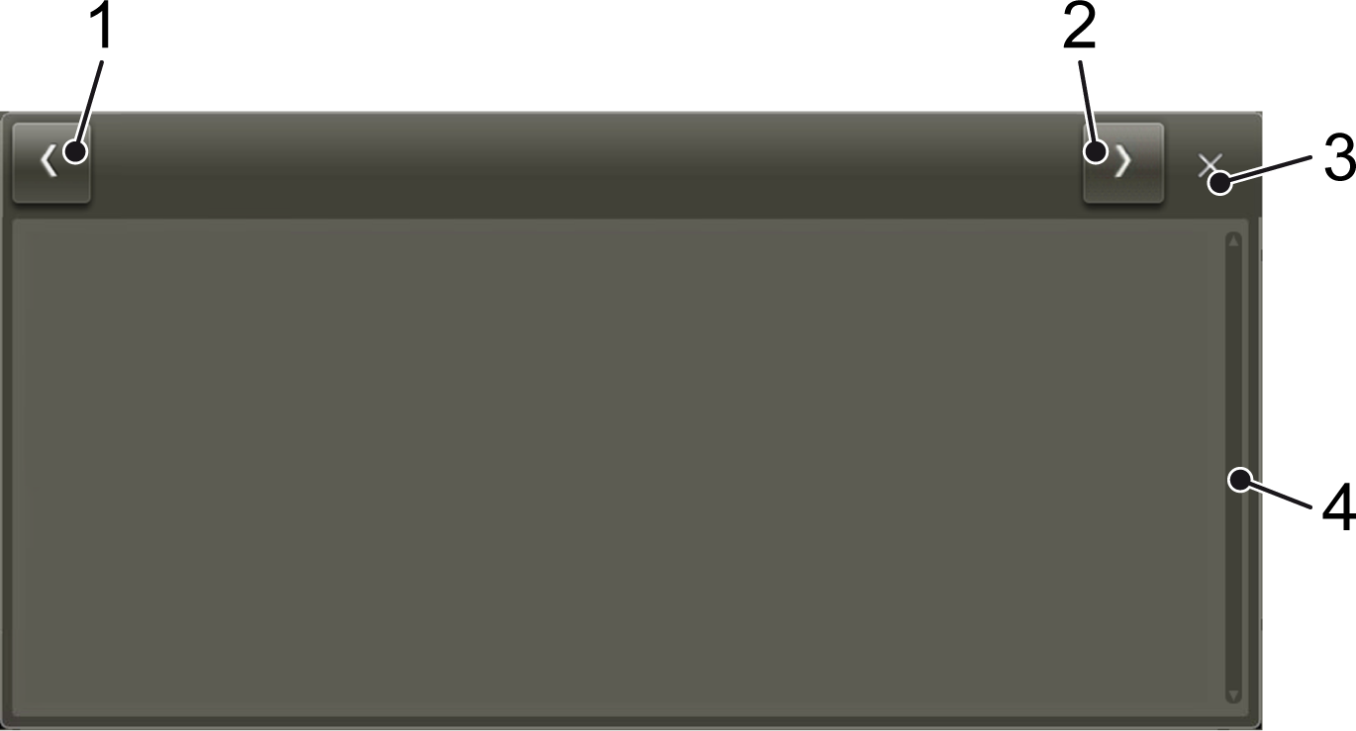

Figure 62: Shifting the visible area of a view
- Arrow for browsing backwards
- Arrow for browsing forwards
- X to close the view
- Scroll bar indicated Touch control

The visible area of a view can be moved by touching the screen, similar to mobile end devices. The touchscreen movements are as follows:

Movement | Meaning
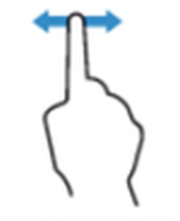 | Moves the visible area up and down or side to side.
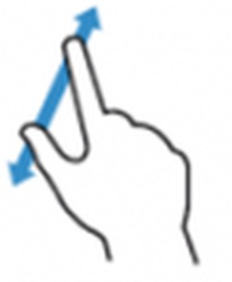 | Enlarges the visible area.
 | Selects an option in a view.

Shifting and scaling
Some views have additional buttons for moving the visible area.

Button | Meaning
 | Enlarge view.
 | Reduce view.
 | Enlarge view step-by-step.
 | Reduce view step-by-step.
 | Move visible area upwards.
 | Move visible area downwards.

Button | Meaning
 | Move visible area to the left.
 | Move visible area to the right.

Assistant
An assistant guides the operator step-by-step through a defined sequence of actions so that the operator can perform a complex
task in a procedure. The operator opens the assistant exactly as they would do with a view.
In general, an assistant consists of several views that the operator works with one after another. The number of views that an assistant has and the position of the current view in the sequence is provided in the title bar.
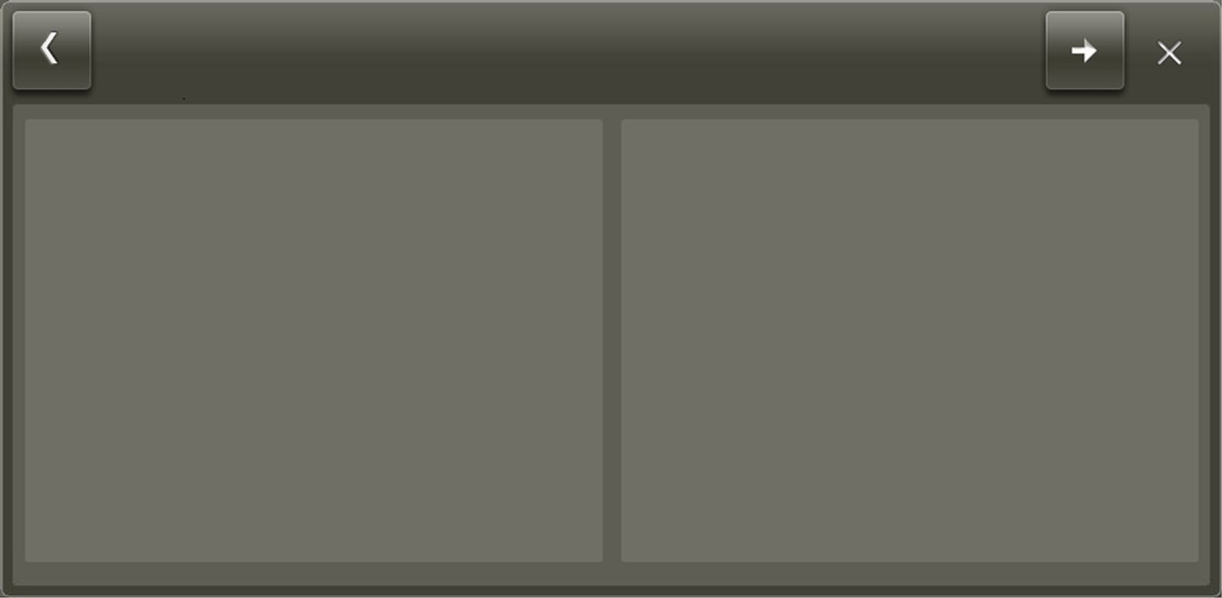

Figure 63: Assistant
The following entries are displayed on the left of view's title bar:
- Name of the assistant
- Position of the current view in the sequence
- Name of the current view

The operator proceeds to the next view of the assistant with .
The final view of the assistant contains buttons to apply or discard the settings made by the operator over the course of this process.

An assistant is not defined for every machine.

Icon bar
The icon bar provides quick access to frequently used functions. Not all functions are available at all times.
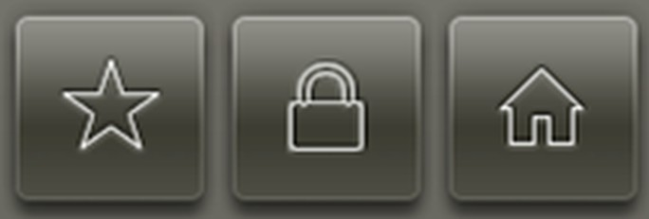

Figure 64: Icon bar

Button | Description | Meaning
 | Favourites  Log in or log out | Opens the ‘Favourites’ dialog, see section  ‘Favourites’.  Opens the ‘User login’ dialog, see section ‘Logging in and off’. If a user is already logged in, the ‘User information’ dialog opens and displays information about the person who is logged in.
 | Main menu | Opens the main menu, see section ‘Main menu.’

Menu bar
The menu bar offers several menus in one row.

Figure 65: Menu bar
Menus combine commands into the following groups:

Icon | Description | Meaning
 | Overview Programs  Messages | Overview of the selected unit Select and adjust a program  Information on messages
 | Type | Type settings and information
 | Parameter | Check and adjust parameters
 | Statistics | Retrieve statistical data
 | Service | Maintenance and service functions
 | Note | Information on the selected unit

Opening a view
Personnel:  Operating personnel
- Tap the corresponding button in the menu bar.
  - If there is only one command in this menu, that view opens immediately.
If several commands are available, touching the icon opens the menu.
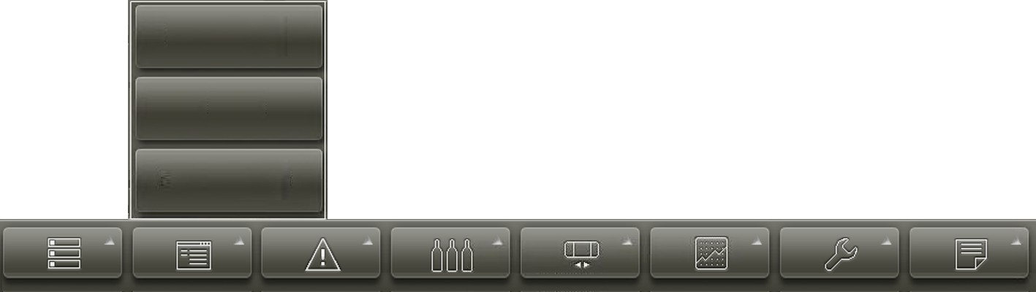

Figure 66: Menu bar with opened menu
- Press the appropriate command.
  - The corresponding view will open in the work area on the dashboard.

Closing the menu
Personnel:  Operating personnel
If the operator has opened the menu, but no longer wishes to select a view:
Tap the menu button again.
  - The menu closes again.

Closing a view
Personnel:  Operating personnel
Tap ‘X’ at the top right of the view.
  - The view will close.

Machine information Machine information dialogue
The ‘Machine information’ dialog opens when the user taps the machine icon. The ‘Machine information’ dialog shows the number and severity of the messages.

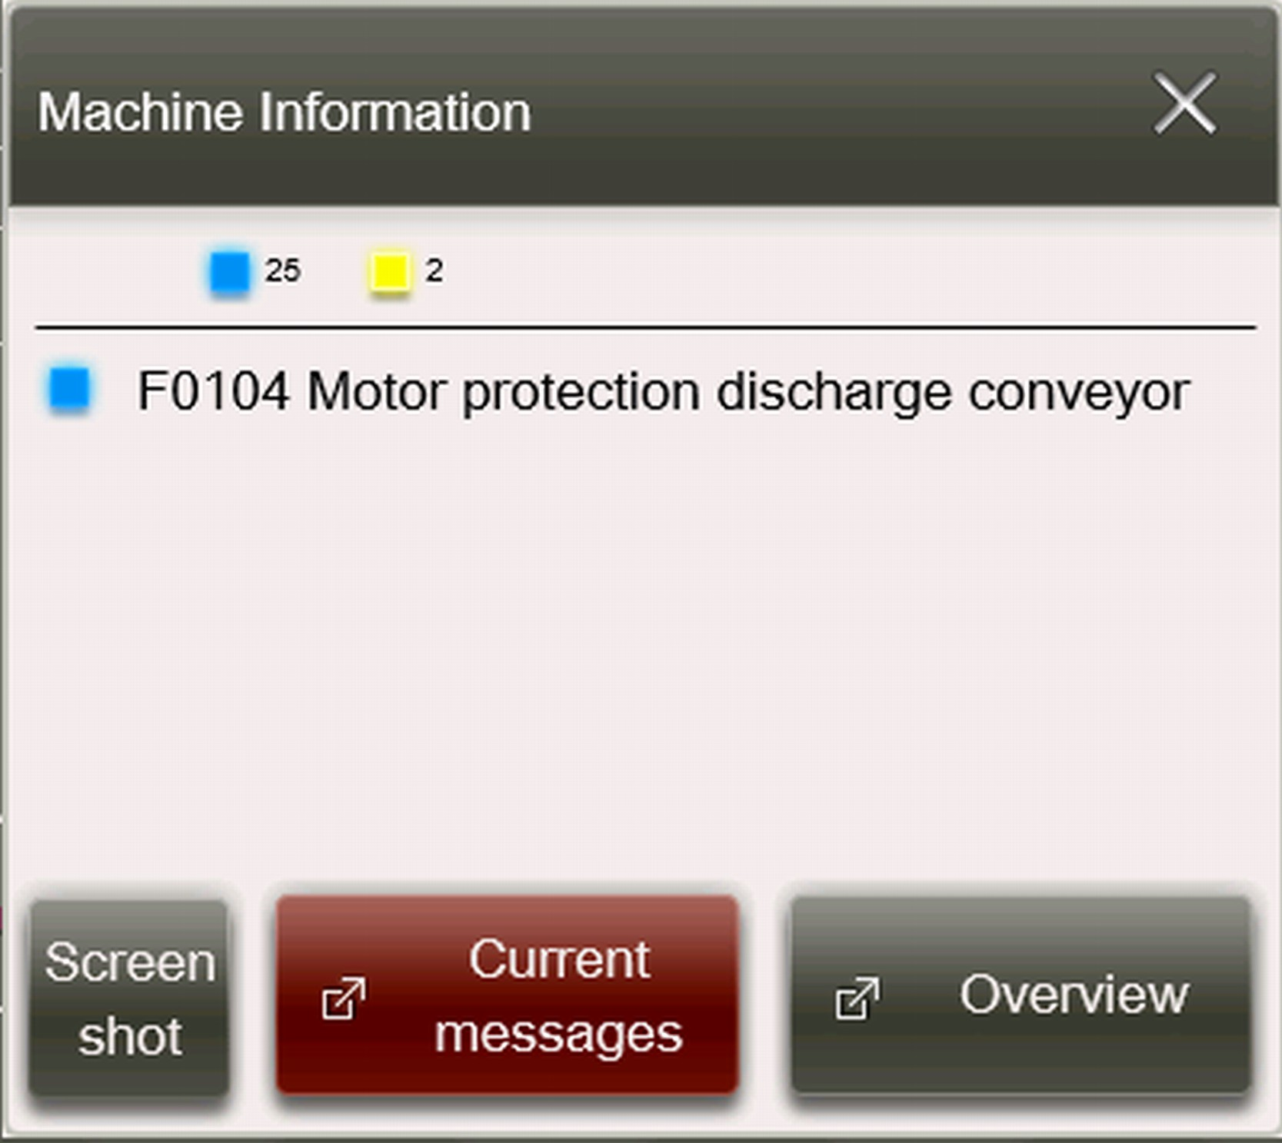

Figure 67: Machine information dialogue
The buttons at the bottom in the dialogue have the following mean‐ ings:

Actions

Button | Meaning
‘Screenshot’ | Takes a picture of the current screen with all open views and saves the screenshot with the image name in the ‘General’ folder. See also the ‘Save to USB’ section in this chapter.  The user can then confirm the finished message in the ‘Save image’ dialogue via ‘Close’ .
‘Current messages’ | Opens the ‘Current messages’ view.
‘Overview’ | Opens the ‘Overview’ view.

      - Input elements
The operator can modify values or settings using input elements. The following elements can be used:

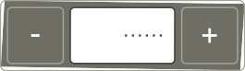
Input element Description Input field

Input field

Button

Option selected
Option not selected

Meaning
Input fields have a white background.
After they are touched, a dialogue with a numerical field or a keyboard opens.
The values in these input fields can be increased or decreased incrementally.

Touching the button triggers an action. The text or icon on the button describes the action.
Options belonging together are grouped in a white frame.
Exactly one option can be selected from this group. Selecting one option from a group deselects the previously selected option.

Option selected
Option not selected
Link
Any desired number of these options can be selected. Options belonging together are grouped in a white frame.

A view or a dialog opens to the left.

Dialogue
Dialogues appear on top of the current view. They can be closed with ‘X’ .

Entering a value
Personnel:  Operating personnel
- Tap the input field.
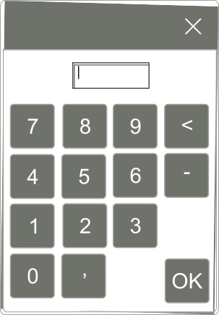

Figure 68: Numerical field
  - A dialogue with a numerical field or a keyboard opens.
- Use the buttons to enter the value.
- Touch ‘OK’ .
  - The dialogue closes and the value is entered in the input field.

The user can cancel the dialog or interrupt an action at any time by pressing ‘X’ .

Buttons
Views can be controlled using buttons. The icons on these buttons have the following meaning:

 | Execute action  Delete |    | Reload  Reset
 | Filter |  | Filter by time
 | Undo |  | Save
 | Manual selection |  | Edit
 | Overview | 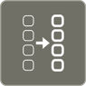 | Details
 | Percent |  | Operating time
 | Abscissa |  | Ordinate
 | Counter |  | Starting
 | Pause |  | Stopping

Output elements
The following elements on the graphical user interface provide infor‐ mation:

Output element | Description | Meaning
 | Output field | Output fields display information such as current actual values.
 | Extended output field | Extended output fields are shown as recessed.  Touching opens a dialogue.
 | Inactive element | All functions are not always available. The corresponding fields are then shown as inactive.
 | Blocked element | Buttons and input fields for which the operator has no authorisation have a lock icon.  Touching opens a dialogue.

Favourites
Saving a view as a favourite
Personnel:  Operating personnel

Touch in a view.
- The current view is saved as a favourite.

Opening a view using favourites Personnel:  Operating personnel

- Touch in the icon bar.
  - The ‘Favourites’ dialogue opens and displays all previously- saved favourites.
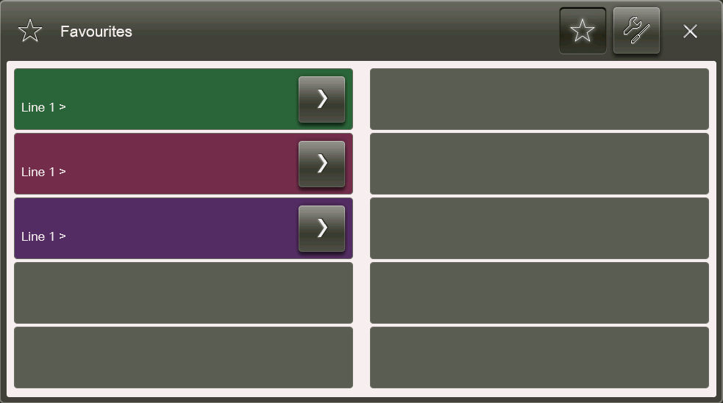

Figure 69: Favourites dialogue
- Touch next to a favourite.
  - The ‘Favourites’ dialogue closes and the selected view opens.

Resorting favourites
Personnel:  Operating personnel
- Touch in the icon bar.
  - The ‘Favourites’ dialogue opens and displays all previously- saved favourites.

- Press .
  - The ‘Favourites settings’ dialogue opens.

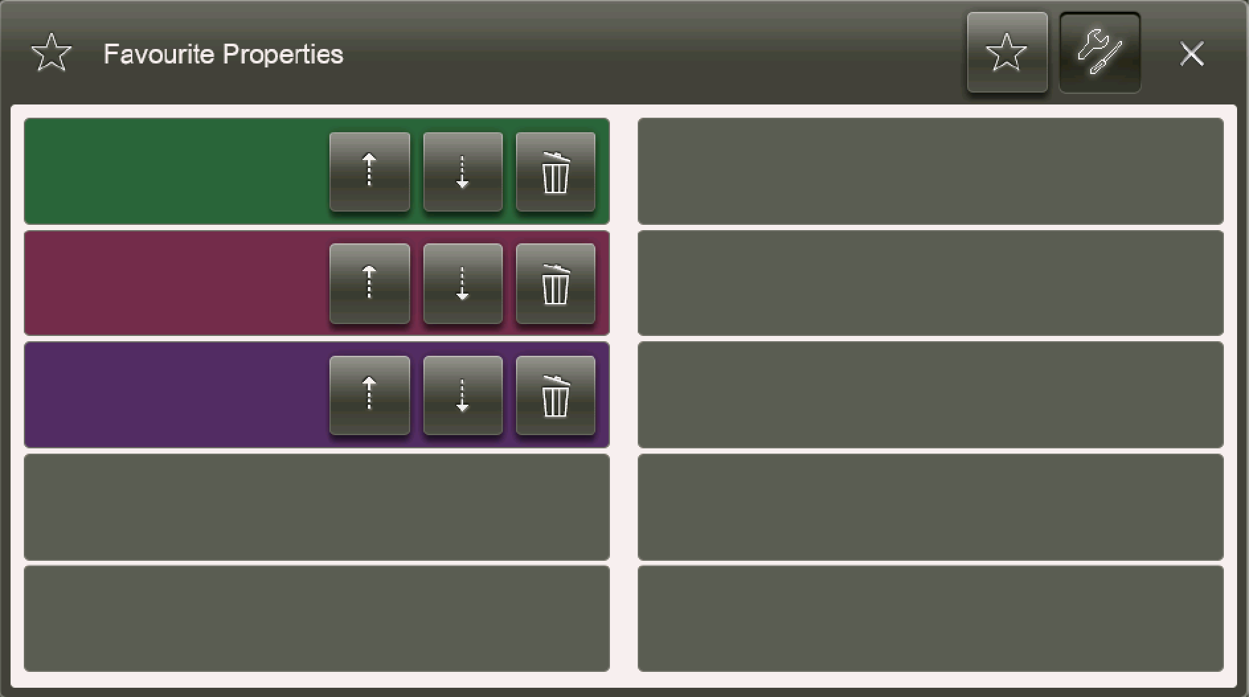

Figure 70: Favourites settings dialogue
- Tap or next to the favourite.
  - The favourite is moved up or down by one row.
- Touch ‘X’ to close the dialogue.

Deleting favourites
Personnel:  Operating personnel
- Touch in the icon bar.
  - The ‘Favourites’ dialogue opens and displays all previously- saved favourites.
- Press .
  - The ‘Favourites settings’ dialogue opens.
- Touch next to the favourite.
  - The favourite has been deleted.
- Touch ‘X’ to close the dialogue.

Logging in and logging out
There are various ways for a user to log in:
- Using an RFID card
- Without an RFID card

Logging in using an RFID card
When the operator logs in for the first time using the RFID card, the RFID card must be held in front of the RFID card reader for at least four seconds.
Personnel:  Operating personnel
Hold the RFID card in front of the RFID card reader on the control panel.
- If a user is already logged in, the ‘RFID card detected’ mes‐ sage will open. The user who is logged in is then logged out and the new user is logged in.
If no other user is logged in, the user is logged in.

In both cases, the user can use the graphical user interface in accord‐ ance with their access authorisation after logging in. The username is displayed in the title bar.

Logging in without an RFID card
If the RFID card has been lost or is faulty, the user can log in using either a password or a PIN code.
- The password is for longer-term access.
- The PIN code is for temporary access.

        - Logging in with a password Personnel:  Operating personnel
- Touch in the icon bar.
  - The ‘User login’ dialog opens.
- Touch ‘User login’ .
  - The ‘User login’ dialog opens.
- Tap the button next to the desired user role.
  - A dialog for entering the password for the selected user role opens.
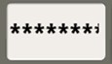
- Tap the input field next to ‘Password’ .
  - A dialog with a numerical keypad opens.
- Enter the password and confirm with ‘OK’ .
  - The dialog with the numerical keypad closes.

- Tap the ‘Login’ button.
  - The ‘User login’ dialog closes and the user is logged in.
The user can use the graphical user interface in accordance with his or her access authorization. Their user role is dis‐ played in the title bar.

Logging in with a PIN code
Logging in with a PIN code involves two steps:
          - First, the user must request temporary access from KHS.
          - The second step is logging in using the temporary access PIN. Requesting temporary access
Personnel:  Operating personnel
- Touch in the icon bar.
  - The ‘User login’ dialog opens.
- Touch ‘Alternative user login’ .
  - A list with different roles opens.
- Select the role from the list for which access is requested.
  - A ‘machine code’ and contact data for the manufacturer are displayed.
- Provide this machine code to KHS via email or telephone to receive temporary access.
  - The manufacturer KHS sends an access code.
- In the ‘Alternative user login’ dialogue, scroll to the next page using .
- Press the first input field.
  - A dialogue with a numerical keypad opens.
- Enter the access code.
- Touch ‘Log in’ .
  - The PIN corresponding to the access code and the validity period of the PIN are displayed.
- Make a note of the PIN.
- Touch ‘OK’ .
  - The ‘Overview’ view opens.

Using temporary access

Personnel:  Operating personnel
- Touch in the icon bar.
  - The ‘User login’ dialog opens.
- Touch ‘PIN login’ .
  - The ‘PIN login’ view opens with an input field.
- Tap the input field.
  - A dialogue with a numerical keypad opens.
- Enter the PIN.
- Touch ‘Log in’ .
  - The ‘User login’ dialogue closes and the user can use the graphical user interface according to their access authorisa‐ tion.

Logging out
For safety reasons, operators are automatically logged off after a certain period of inactivity.

Users can log out in several ways:
- With the RFID card.
- With in the icon bar.

Logging out using an RFID card Personnel:  Operating personnel
To log out, hold the RFID card in front of the RFID card reader again.
  - A message opens and the user is logged out. After logging out, the user name no longer appears in the title bar.

Logging out via
Personnel:  Operating personnel
- To log out, touch in the icon bar.
  - The ‘User information’ dialogue opens. This shows the role, user name and the set language of the user.

- Touch ‘Log out’ .
  - The user is logged out. After logging out, the user name no longer appears in the title bar.
- Touch ‘Cancel’ .
  - The user remains logged in.

User roles
Users can be assigned roles. A role is a summary of rights which are defined system-wide.
The role determines the following:
- What the user sees in the program.
- What the user may and may not do. The following roles are available:
- The operator ( ‘Operator’ ) belongs to the operating personnel. Operators monitor the automated processes, regulate the mate‐ rial flow and operate the machine in automatic mode. In auto‐ matic mode, operators can correct minor and frequently occurring issues. Operators have blue RFID key fobs.
- The foreman or shift manager ( ‘Technical Supervisor’ ) belongs to the maintenance personnel. This person is responsible for mul‐ tiple machines and oversees multiple operators. Technical Super‐ visors have yellow RFID key fobs.
- The stand-by operator ( ‘Stand-by personnel’ ) belongs to the maintenance personnel and performs various tasks on different machines as required. Stand-by personnel have yellow RFID key fobs.
- Quality assurance personnel ( ‘Quality assurance’ ) belong to the maintenance personnel. Quality assurance personnel control the product quality, take laboratory samples and evaluate them. Quality assurance personnel have yellow RFID key fobs.
- The service engineer ( ‘Maintenance Staff’ ) belongs to the main‐ tenance personnel and is called in the event of issues and
faults which they cannot resolve on their own. Service engineers operate functions in automatic and setup mode. They can also switch to teleservice mode. Service engineers have green RFID key fobs.
- The Administrator belongs to the specialist personnel commis‐ sioned by KHS. An administrator performs administrative tasks and assigns access rights. Administrators have red RFID key fobs.
Users identify themselves at the control unit using the RFID key fob. The RFID key fobs are colour-coded and role-dependent.
The table shows which functions are assigned to a role (factory set‐ ting). The function must be relevant to the machine.

Function | Oper‐ ator | Forema n/shift man‐ ager | Stand- by oper‐ ator | Quality assur‐ ance | Service engi‐ neer for mechani cs | Service engi‐ neer for elec‐ trical system | Admin‐ istrator
Current messages | Yes | Yes | Yes | -- | Yes | Yes | Yes
Message history | Yes | Yes | Yes | Yes | Yes | Yes | Yes
Reset to factory settings | -- | -- | -- | -- | -- | -- | Yes
Service functions | -- | Yes | -- | -- | Yes | Yes | Yes
Extended service functions | -- | -- | -- | -- | Yes | Yes | Yes
Function activa‐ tions | Yes | Yes | Yes | -- | Yes | Yes | Yes
Capacity | Yes | Yes | Yes | -- | Yes | Yes | Yes
Change product parameters | -- | Yes | -- | -- | Yes | Yes | Yes
Program selection | Yes | Yes | -- | Yes | Yes | Yes | Yes
Starting the pro‐ gram | Yes | Yes | Yes | Yes | Yes | Yes | Yes
Manage type data | -- | Yes | -- | -- | Yes | Yes | Yes
Type selection | Yes | Yes | Yes | -- | Yes | Yes | Yes
View statistics | Yes | Yes | Yes | Yes | Yes | Yes | Yes
Backup/restore graphical user interface | -- | -- | -- | -- | -- | Yes | Yes

Main menu
The ‘Main menu’ opens when the user taps in the icon bar

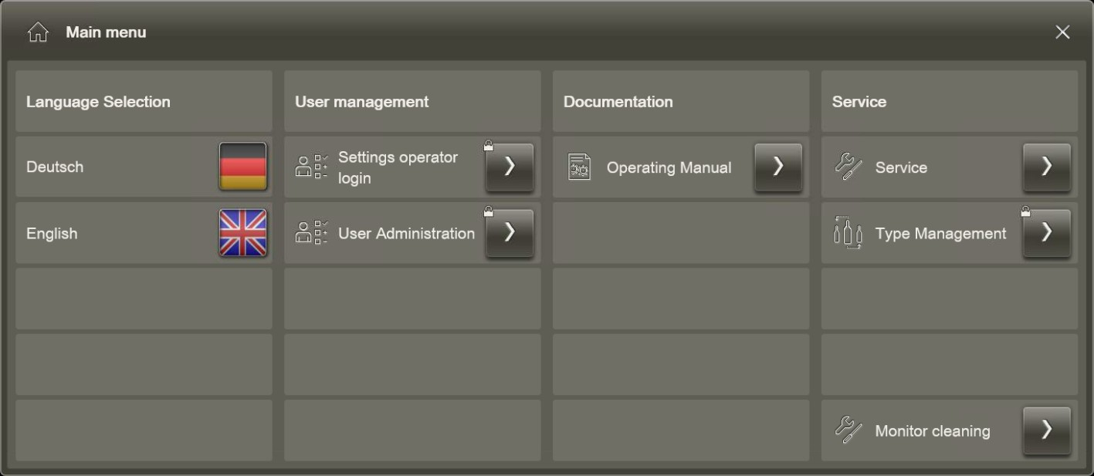

Figure 71: Main menu
The ‘Main menu’ contains the following submenus:

Submenu | Meaning
‘Language selection’ | Displays the available languages for the user interface of the machine.  If there are more than four languages avail‐ able for the user interface, the user can open the ‘Language selection’ dialogue and set the language there.
‘User administration’ | These functions are locked for the user.
‘Documentation’ | Opens a dialogue with the available doc‐ umentation, e.g. instructions for this user interface
‘Service’ | Opens further submenus for the accessible functions.

Setting the language
When a user logs in using their RFID key fob, the graphical user interface for the machine is displayed in the set language. Users can change this language setting.
Personnel:  Operating personnel
- Use to open the ‘Main menu’ .
- In the ‘Main menu’ , tap the flag icon in the ‘Language selection’
submenu.
  - The language of the user interface is changed.

The language set on the RFID key fob does not change if the user manually selects a different lan‐ guage.

Service submenu
The ‘Service’ submenu contains the following commands that the user uses to set the graphical user interface:

Command | Meaning
‘Temperature’ | Opens the ‘Temperatures’ view with an over‐ view of the temperature values for the com‐ puter's components.
‘Drives’ | Opens the ‘Drive system information’ view with an overview of drive utilisation on the computer.
‘Time setting’ | Opens the ‘Time setting’ view where the user can set the time for the graphical user inter‐ face.
‘Network settings’ | Opens the ‘Network settings’ view where the user can access information about the net‐ work settings.
‘Backup/restore’ | Opens the ‘Backup/restore’ view. These functions are locked for the user.
‘Save to USB’ | Opens the ‘Save to USB’ view, in which the user can save selected data to a USB stick.
‘RFID settings’ | Opens the ‘RFID settings’ view where the user can access the RFID settings.

Command | Meaning
‘Reset to factory settings’ | Resets the settings in the graphical user inter‐ face back to the defaults.
‘Display the mouse cursor’ | Shows the mouse pointer on the screen.

Temperatures
The ‘Temperatures’ view can be opened via ‘Main menu ➔ Service
➔ Temperatures’. The view shows the temperature values for the computer components on which the graphical user interfaces run.
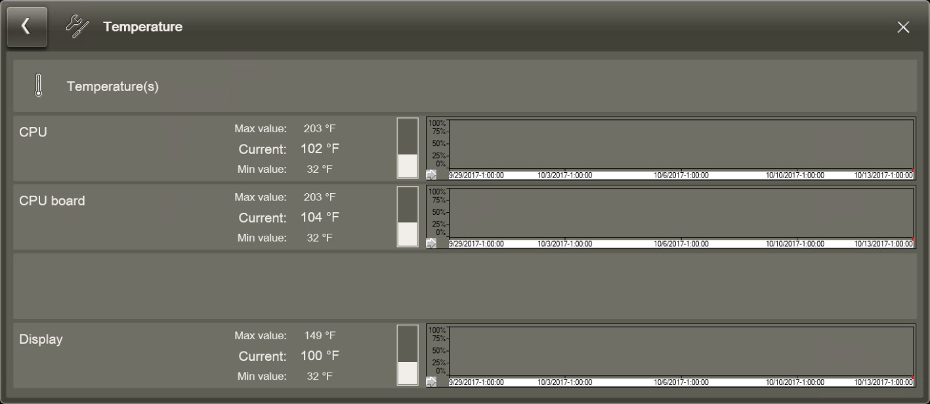

Figure 72: ‘Temperatures’ view

Drive system information
The ‘Drive system information’ view can be opened via ‘Main menu
➔ Service ➔ Drive system information’. The view shows the utilisa‐ tion of the computer drives on which the graphical user interfaces run.
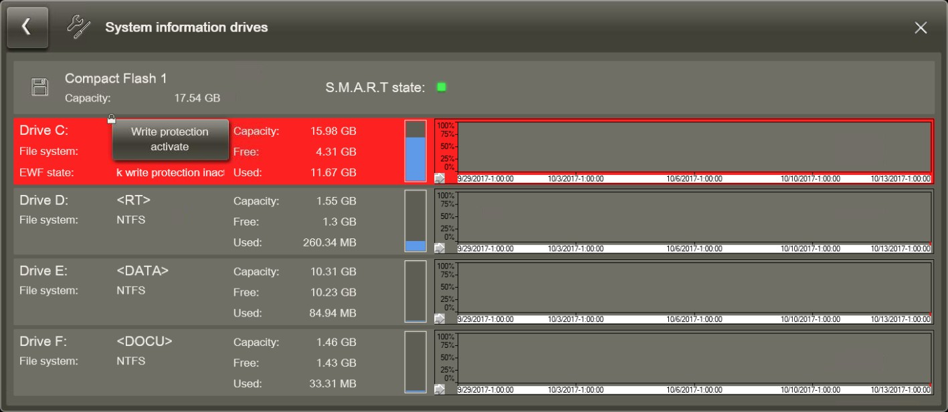

Figure 73: ‘Drive system information’ view
The ‘S.M.A.R.T status’ displays the status of the memory card (cFast).

Time setting
The ‘Time setting’ view can be opened via ‘Main menu ➔ Service

➔ Time setting’.
The operator can configure the following time parameters:
          - the time on the computer (BIOS)
          - whether the time on the computer should be displayed in the 12-hour or 24-hour clock format (BIOS)
          - the zone time (select from the dropdown list)
          - whether the time should be automatically updated at the start and end of daylight saving time
The user cannot change the date.
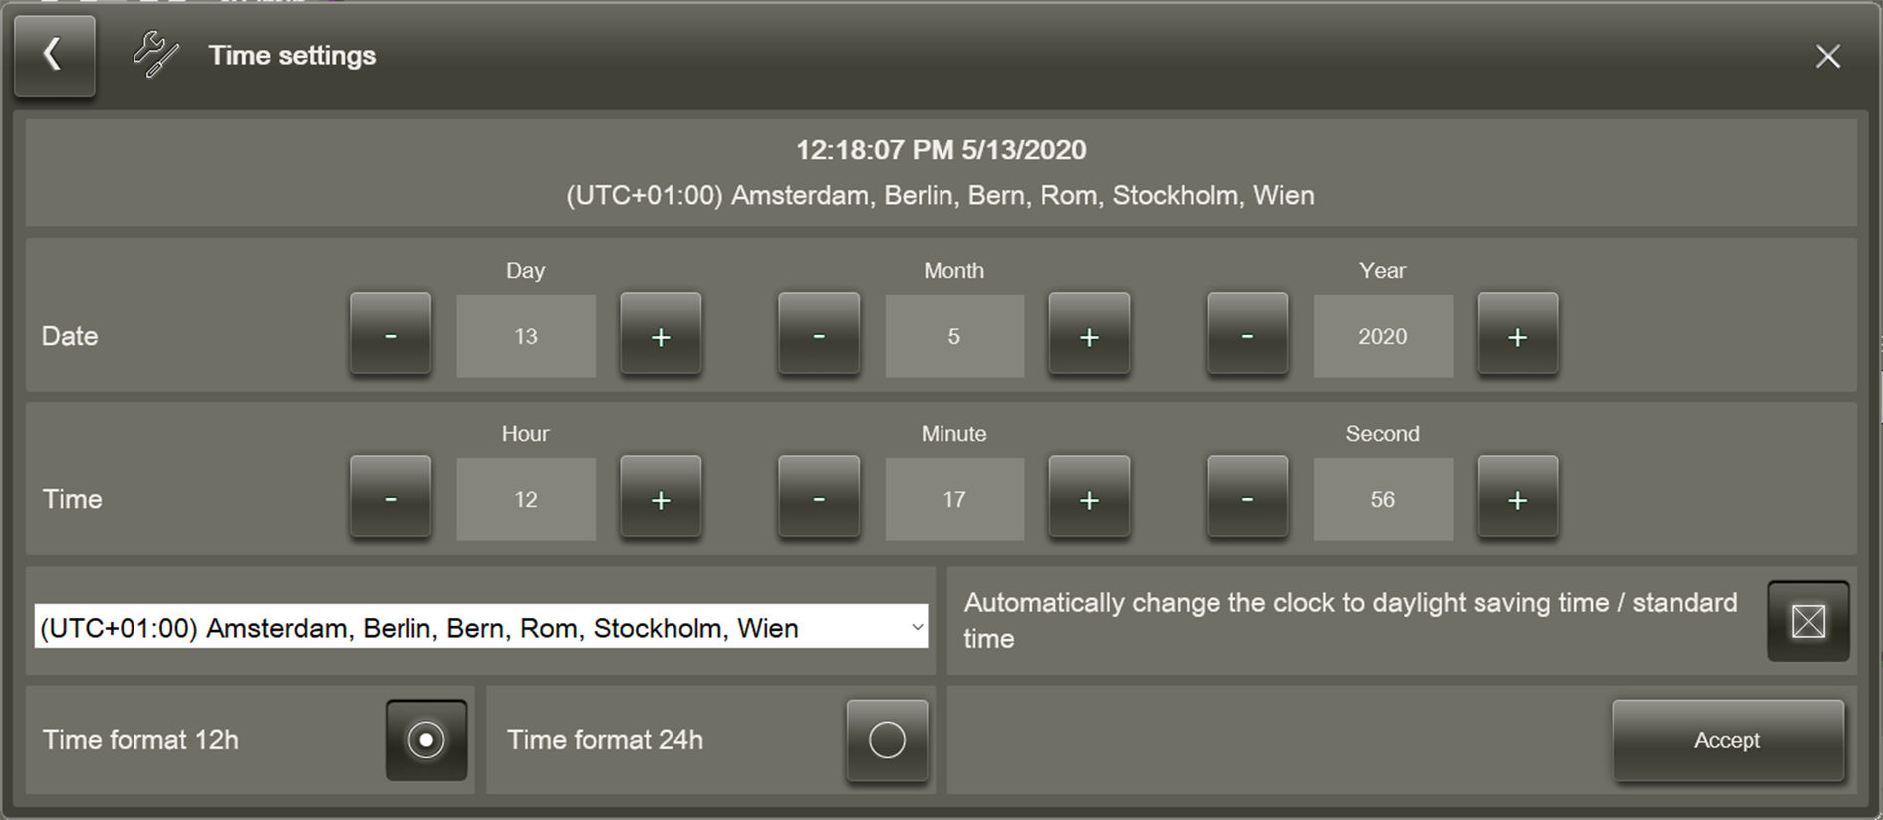

Figure 74: ‘Time setting’ view

Network settings
The ‘Network settings’ view can be opened via ‘Main menu
➔ Service ➔ Network settings’. The user can access the current network settings in this view.
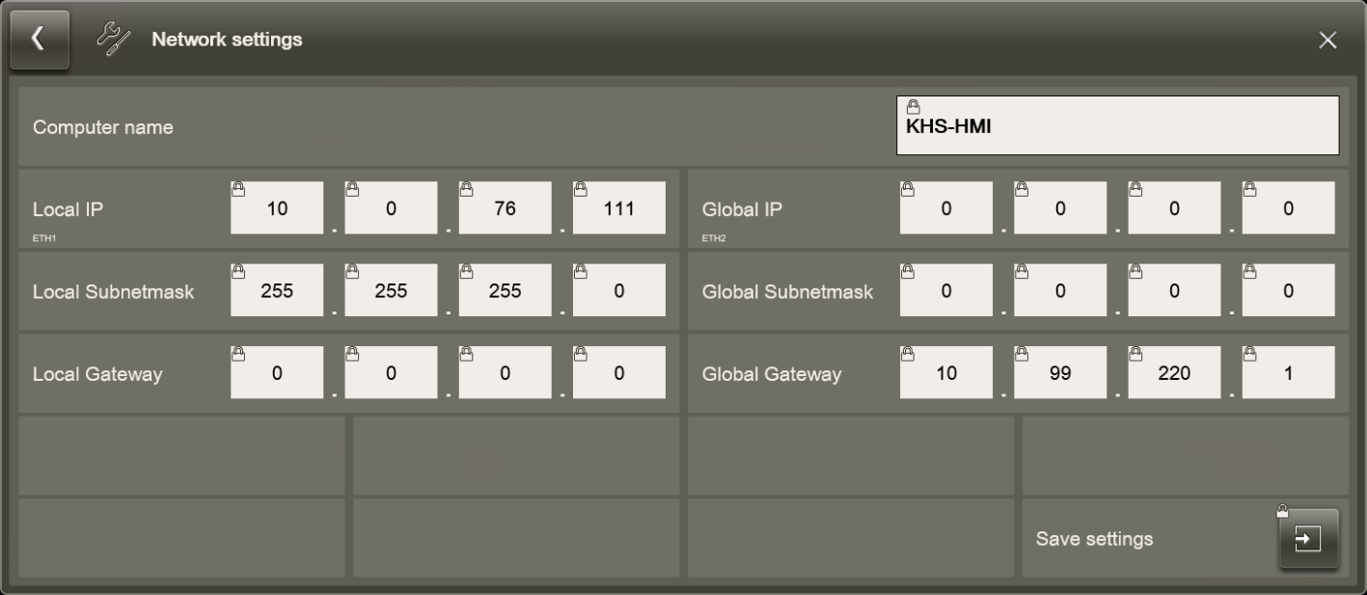

Figure 75: ‘Network settings’ view

Backup/restore
The ‘Backup/restore’ view can be opened via ‘Main menu ➔ Service
➔ Backup/restore’. The functions in this view are locked for the user.
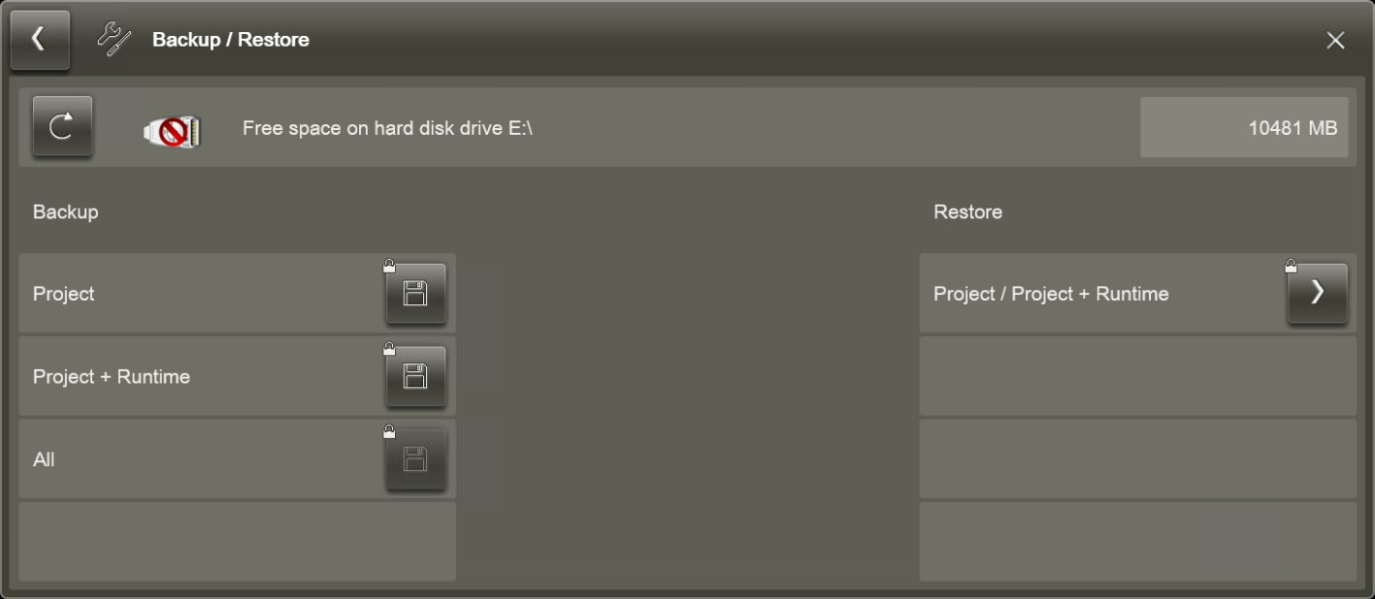

Figure 76: ‘Backup/restore’ view
The top row displays the storage media and the free memory space. The user can toggle between storage media using . In doing so, the colour on the USB icon indicates whether the USB stick is selected or not:

Colour | Meaning
Red | The USB stick is not selected and E:\ is the storage medium.
Green | The USB stick is selected as the storage medium.

Save to USB
USB sticks can be a security risk. Only use USB sticks that have been checked by an antivirus programme.
The ‘Save to USB’ view is opened via ‘Main menu ➔ Service
➔ Save to USB’. In this view, the user can move various data onto a USB stick that was previously saved on disk.

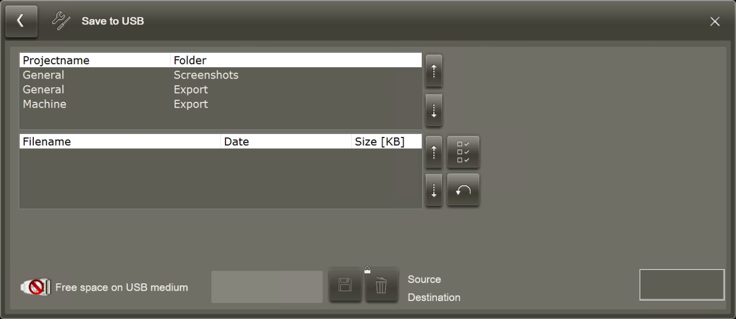

Figure 77: ‘Save to USB’ view
Both lists show the contents of the folder on the disk where the user can save data, e.g. screenshots.
          - The top list shows the folder on the disk.
          - The bottom list shows the contents of the folder that the user has selected in the top list.

Icon | Meaning
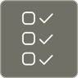 | Selects all data in the bottom list that is to be moved to the USB stick.
 | Resets the selection.
 | Saves the selected data to the USB stick.
 | Function not authorised for the user.
 | The colour on the USB icon indicates whether a USB stick has been inserted or not:  - Red: the USB stick has not been inserted and data cannot be saved.  - Green: the USB stick is ready for use as a storage medium.
‘100%’ | Indicates that the transfer was completed suc‐ cessfully.

RFID settings
The ‘RFID settings’ view can be opened via ‘Main menu ➔ Service
➔ RFID settings’. The user can find out about the current settings for the RFID system in this view.

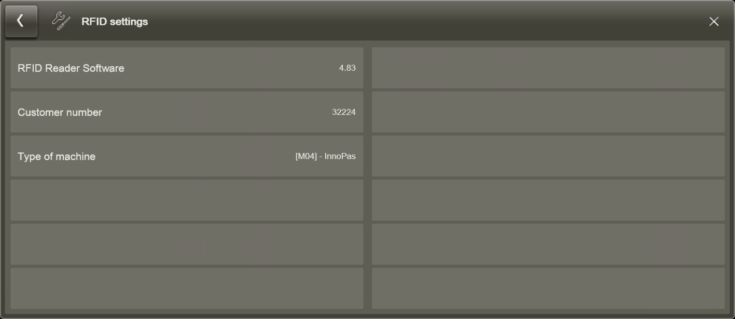

Figure 78: ‘RFID settings’ view

Cleaning the screen
The user can switch off the touch sensitivity of the touchscreen for 30 seconds to clean the screen.
Personnel:  Operating personnel
- In the Main menu, select the ‘Clean screen’ command.
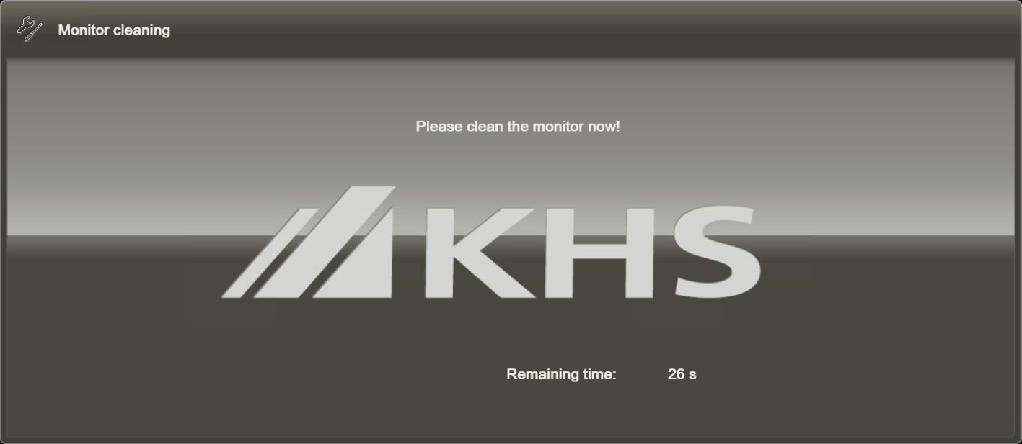

Figure 79: Fixed image for cleaning the screen
  - The image on the screen is frozen and a seconds counter is displayed to count down the seconds until the touchscreen will react to touch again.
- If cleaning has not been completed by the end of the count‐ down, tap ‘Clean screen’ again.

    - NatureMultiPacker
      - Dashboard
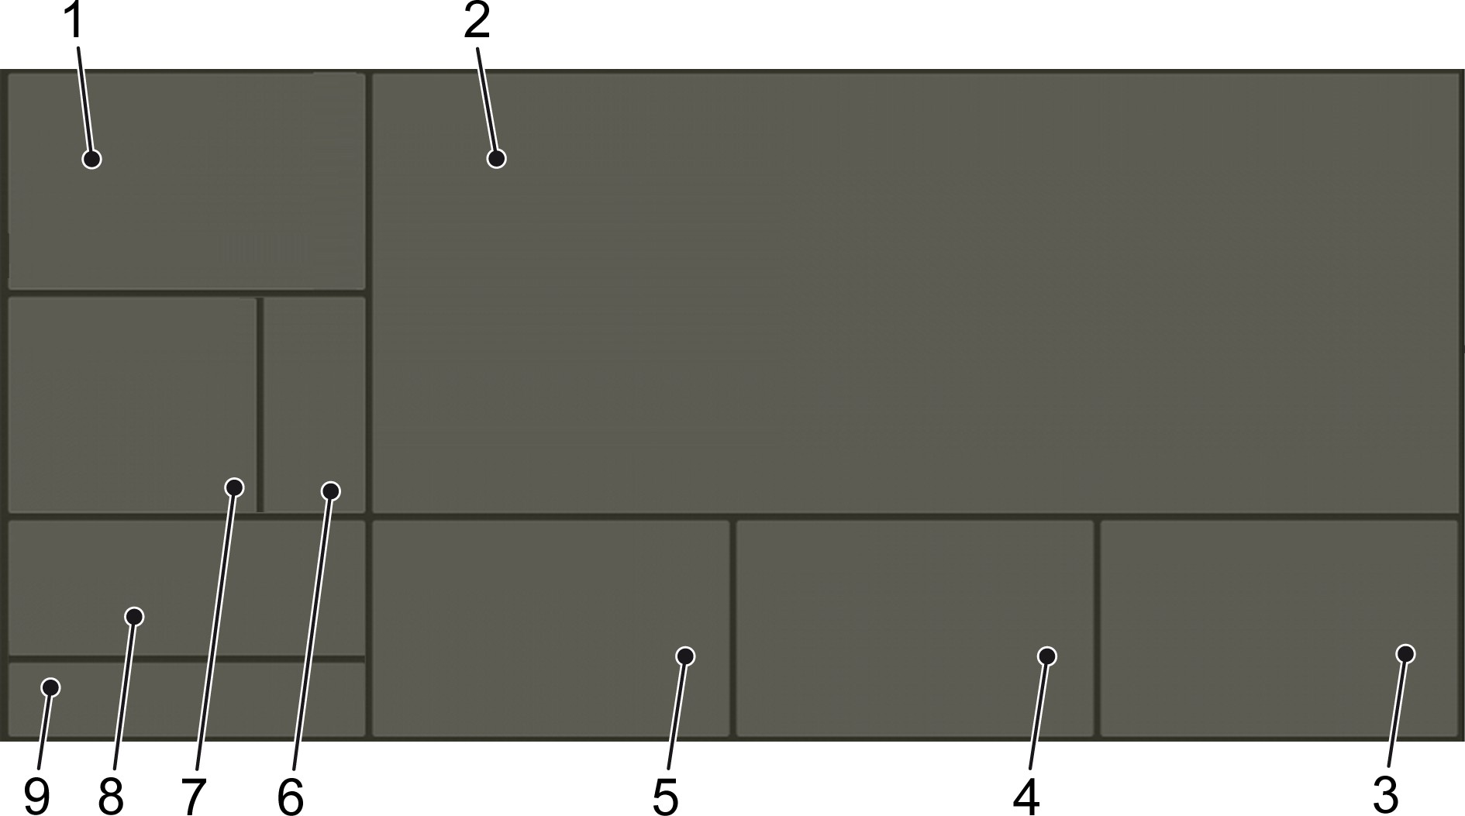

Figure 80: Layout of the dashboard
- Information/statistics
- Machine overview
- About... /position indicator/signals
- Jobs
- Process modules/components
- Function activations
- Selection buttons
- Functions
- Status displays

Menu structure
The table shows the menu commands applicable to the entire machine. The user opens the associated view with the commands.

Icon | Name | Command
 | ‘Overview’ ‘Programs’ | ‘Alignment (Sencon)’  ‘Functions’ ‘Program selection’
 | ‘Messages’ | ‘Current messages’
 | ‘Messages’ | ‘Message history’
 | ‘Type’ | ‘Current type’
 | ‘Type’ | ‘Type selection’

Icon | Name | Command
 |  | ‘Selection buttons’
 | ‘Parameter’ | - For qualified personnel only
 | ‘Statistics’ | ‘Pack counter’
 | ‘Statistics’ | ‘Operating hours’
 | ‘Statistics’ | ‘Power monitor’
 | ‘Service’ | ‘Service functions’
 | ‘Service’ | ‘Service functions servo drives’
 | ‘Service’ | ‘Servo drives’
 | ‘Service’ | ‘Manual lubrication’
 | ‘Service’ | ‘Service Functions General’
 | ‘Service’ | ‘Packer service functions’
 | ‘Service’ | ‘Status model’
 | ‘Service’ | ‘Run in/run out’
 | ‘Service’ | ‘Machine setup’
 | ‘Note’ | ‘About...’

      - ‘Overview’ menu

‘Alignment (Sencon)’ view
The ‘Alignment (Sencon)’ view can be opened by selecting ‘Overview
➔ Alignment (Sencon)’ and displays all the alignment functions.
This view contains the user interface for the cameras in the "Align‐ ment (M53)" process module. It is needed to load a saved label or to train in a new label.
          - See the ‘Loading a label’ section in the chapter entitled ‘Pre‐ paring for operation’
          - See the ‘Training in a label’ section in the chapter entitled ‘Setup’
The view opens in a window in front of the view area. After settings have been adjusted, close the window via the X in the top right-hand corner.
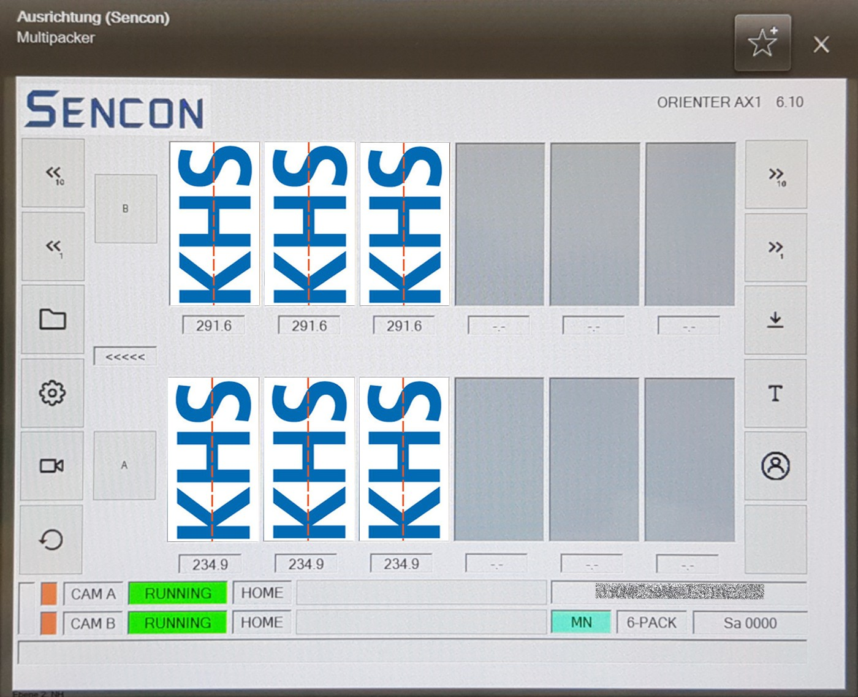

Figure 81: ‘Alignment (Sencon)’ view

Element | Description
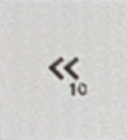 | Left turn, rough  The product is turned left by 9°.
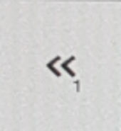 | Left turn, fine  The product is turned left by 0.9°.

Element | Description
 | Label selection Load a saved label.
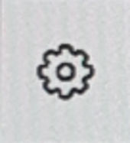 | Correction of deviations in rotation Only for qualified personnel!
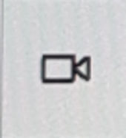 | Live camera images
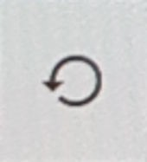 | Main menu
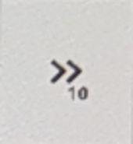 | Right turn, rough  The product is turned right by 9°.
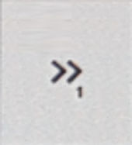 | Right turn, fine  The product is turned right by 0.9°.
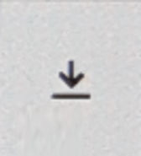 | Save label  Save the current label and the settings.
 | Train in a label  Open a selection menu containing existing labels and empty storage locations. Start the training process for a label. See the ‘Training in a label’ section in the chapter entitled ‘Setup’.
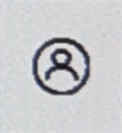 | User login
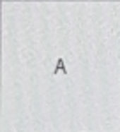 | Select right alignment station  For joint alignment of all labels in the right row.
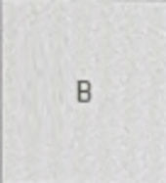 | Select left alignment station  For joint alignment of all labels in the left row.
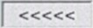 | Production direction

Element | Description
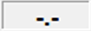  different values | Displays the rotation angle  Selection of a single product. For alignment of a single label.
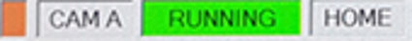 | Displays the operating status and the target position
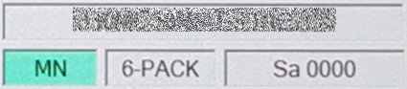 | Displays the loaded label type, the operator who is logged in and the container size

      - ‘Programs’ menu
        - ‘Functions’ view
To open the ‘Functions’ view, select ‘Programs ➔ Functions’. this view can be used to switch some functions on and off.
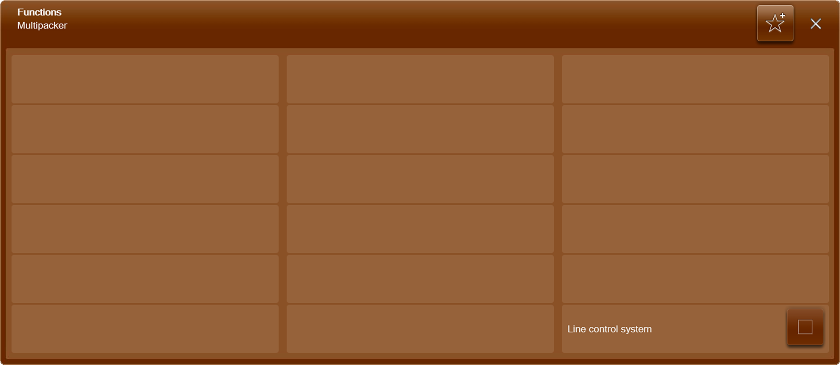
Figure 82: ‘Functions’ view

Element | Description
‘System control’ | Switches the system control on and off  If system control is activated, the produc‐ tion speed of the machine is determined by the speed of the entire system, i.e. via external signals.

‘Program selection ’ view
The ‘Program selection’ view is opened via ‘Programs ➔ Program selection’.
The operator can select and close a program in this view.
The selection of the correct program is important in order to record operating data correctly.
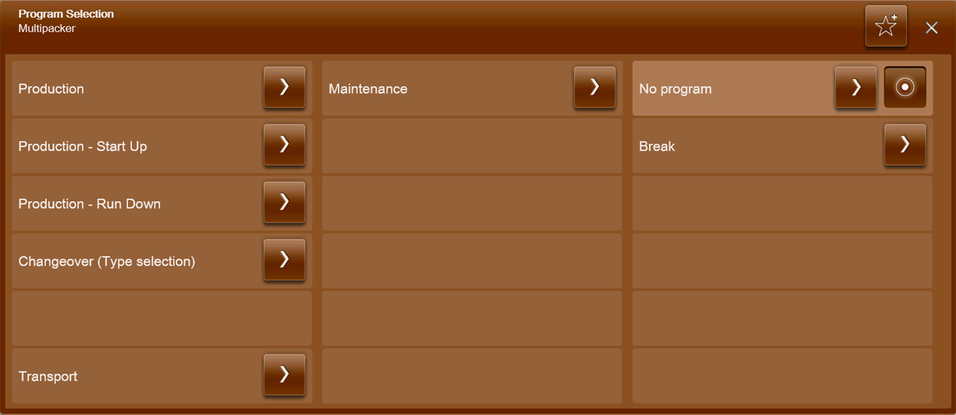

Figure 83: ‘Program selection ’ view

Element | Description
‘Production’ | Selection for production.  The ‘Program selection’ view is closed. The dashboard is displayed.
‘Production – run in’ | Selection for start up.  The ‘Run in/Run out’ view opens. ‘Run in’ can be selected here.
‘Production – run out’ | Selection for run down.  The ‘Run in/Run out’ view opens. ‘Run out’ can be selected here.
‘Setup (type selection)’ | Selection for setting the machine up for  a different type. See chapter ‘Operation’, section ‘Setup’.  The ‘Type selection’ screen opens.

Element | Description
‘Run-through mode’ | Select if the products are to be trans‐ ported through the machine without being packed. Only the conveyor belts and chains are activated. The type selected must be suitable for run-through mode otherwise a fault message is issued.  The ‘Program selection’ view is closed. The dashboard is displayed.
‘Maintenance’ | Selection for machine maintenance. See the ‘Maintenance’ chapter.  The ‘Program selection’ view is closed. The dashboard is displayed.
‘No program’ | Ends a program.  The ‘Program selection’ view is closed. The dashboard is displayed.
‘Pause’ | Selection for pausing production.  The ‘Program selection’ view is closed. The dashboard is displayed.

      - ‘Messages’ menu

‘Current messages ’ view
The ‘Current messages’ view is opened via ‘Messages ➔ Current messages’.
This view displays current messages. Once the fault has been recti‐ fied, the fault message switches to the fault memory.

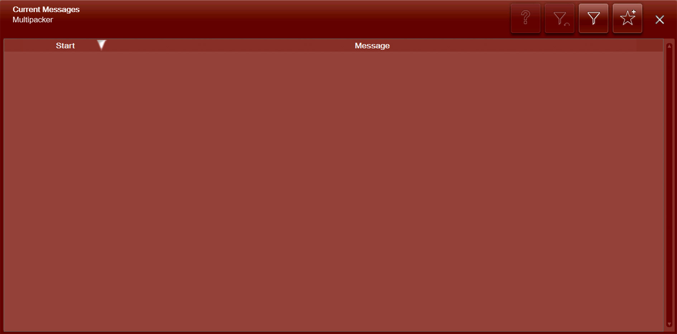

Figure 84: ‘Current messages ’ view

Filtering messages
Personnel:  Operating personnel
- Press .
  - The ‘Filter’ dialogue opens containing filter settings.
- Choose a filter setting.
- Select ‘OK’ .
  - The dialogue closes and the messages are sorted according to the filter.

Resetting the filter
Personnel:  Operating personnel
A filter is selected.
- Press .
  - The ‘Filter’ dialogue opens containing filter settings.
- Deselect filter settings.
- Select ‘OK’ .
  - The dialogue closes and the messages are displayed unfil‐ tered.

‘Message history’ view
The ‘Message history’ view is opened via ‘Messages ➔ Message history’.
This view displays a list of the messages that have been triggered on the machine in the past. Faults displayed here have already been eliminated and are no longer up-to-date.
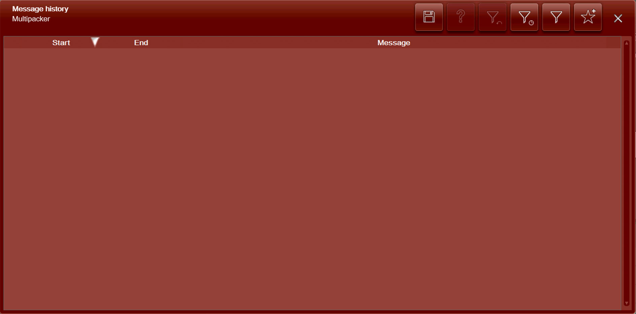

Figure 85: ‘Message history’ view
Processed fault messages can be sorted in exactly the same way as current fault messages. The fault messages can also be sorted by time.

Filter messages by time
Personnel:  Operating personnel

- Press .
  - The ‘Time filter’ dialogue opens containing settings.
- Select period.
- Select ‘OK’ .
  - The dialogue closes and the messages for the period chosen are displayed.

Resetting the filter
Personnel:  Operating personnel
A filter is selected.
- Press .
  - The ‘Time filter’ dialogue opens and shows the filter settings.

